**Spring 2019**

**CSE 5330 – Database Systems 1**

**Project 2 Phase 1**

**Conceptual Schema Database Schema**

**Project Members:**

Balaji Gurumoorthy – 1001680348

Goutami Padmanabhan – 1001669338

**Professor:** Bhanu Chaturvedi Jain

**Honor Code**

I pledge, on my honor, to uphold UT Arlington's tradition of academic integrity, a tradition that values hard work and honest effort in the pursuit of academic excellence.

I promise that I will submit only work that I personally create or that I contribute to group collaborations, and I will appropriately reference any work from other sources. I will follow the highest standards of integrity and uphold the spirit of the Honor Code.

Balaji Gurumoorthy Goutami Padmanabhan

I pledge, on my honor, to uphold UT Arlington's tradition of academic integrity, a tradition that values hard work and honest effort in the pursuit of academic excellence.**CREATE Queries**

CREATE DATABASE WORLDCUP;

USE WORLDCUP;

CREATE TABLE TEAM(

TeamID VARCHAR(5) NOT NULL,

Team VARCHAR(100) NOT NULL,

Continent VARCHAR(50) NOT NULL,

League VARCHAR(8) NOT NULL,

Population INT(10) NOT NULL,

PRIMARY KEY(Team),

UNIQUE KEY(TeamID)

);

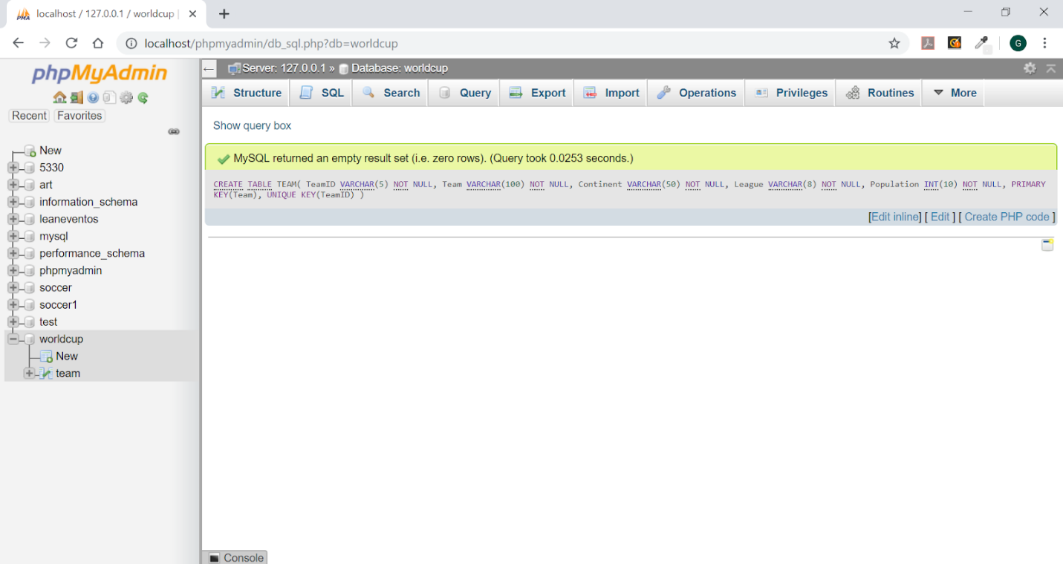

CREATE TABLE STADIUM(

   SId VARCHAR(3) NOT NULL,

   SName VARCHAR(100) NOT NULL,

   SCity VARCHAR(100) NOT NULL,

   SCapacity INT(10) DEFAULT NULL,

   PRIMARY KEY(SId, SName),

   UNIQUE KEY(SId)

);

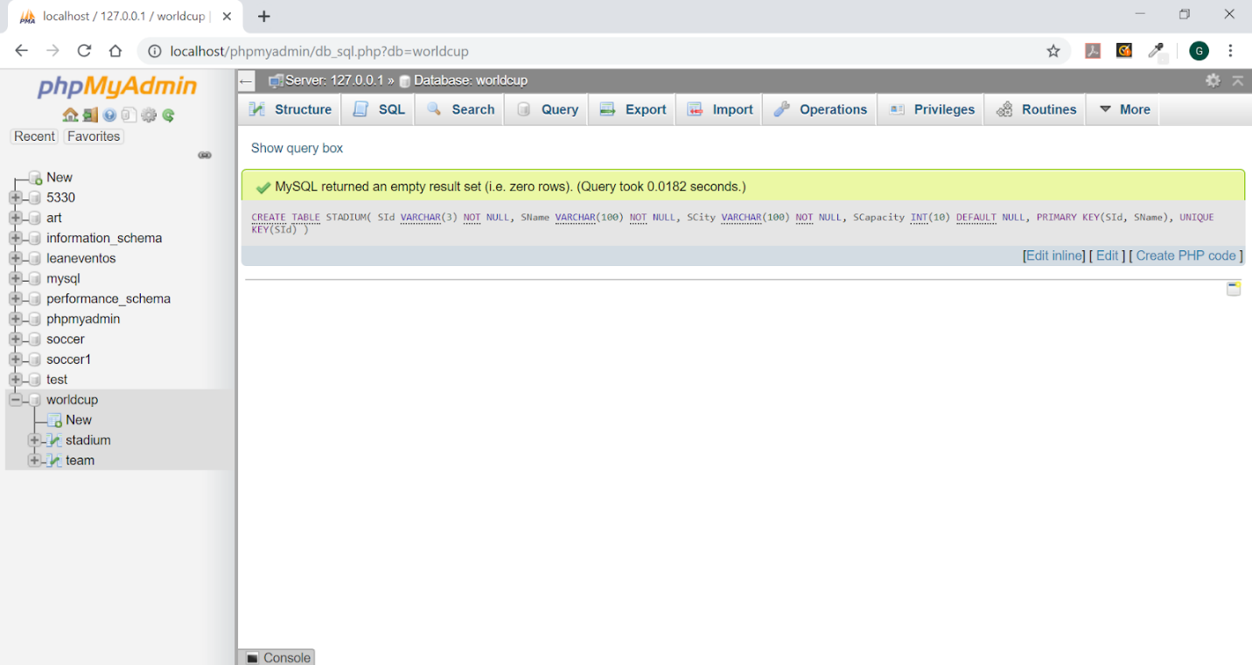

CREATE TABLE PLAYER(

   Team VARCHAR(100) NOT NULL,

   TeamID VARCHAR(5) NOT NULL,

   PNo INT(10) NOT NULL,

   POSITION VARCHAR(2) NOT NULL,

   PName VARCHAR(100) NOT NULL,

   BirthDate VARCHAR(10) DEFAULT NULL,

   ShirtName VARCHAR(50) NOT NULL,

   Club VARCHAR(100) DEFAULT NULL,

   Height INT(10) DEFAULT NULL,

   Weight INT(10) DEFAULT NULL,

   PRIMARY KEY(PNo,Team,TeamID,POSITION),

   FOREIGN KEY(TeamID) REFERENCES Team(TeamID)

);

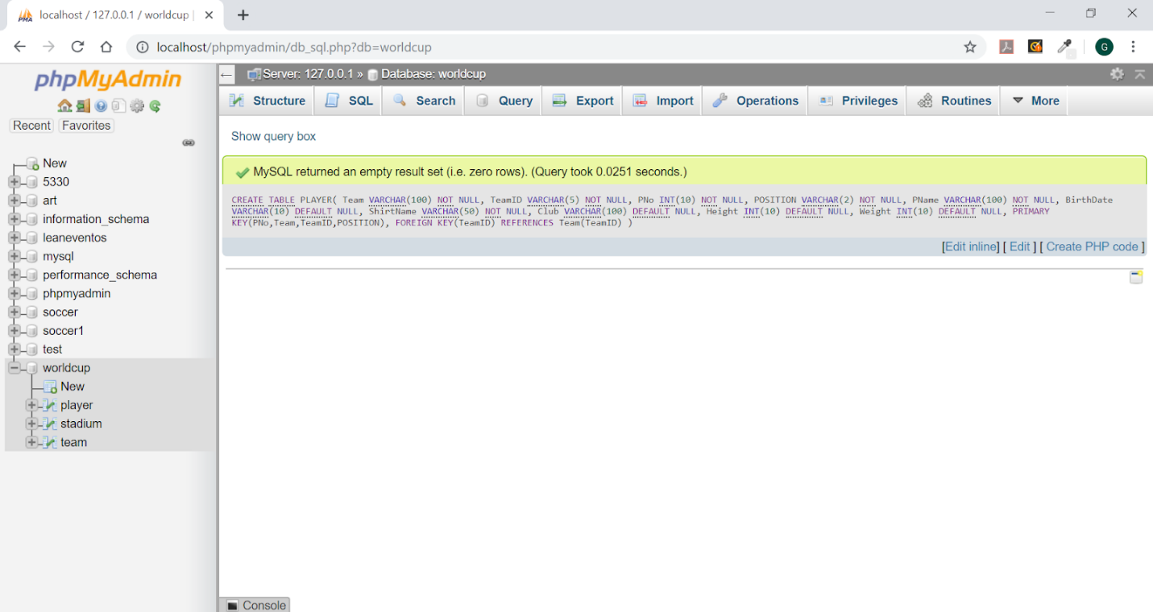

CREATE TABLE GAME(

   GameID VARCHAR(3) NOT NULL,

   MatchType VARCHAR(50) NOT NULL,

   MatchDate VARCHAR(10) NOT NULL,

   SId VARCHAR(3) NOT NULL,

   TeamID1 VARCHAR(5) NOT NULL,

   TeamID2 VARCHAR(5) NOT NULL,

   Team1_Score INT(10) NOT NULL,

   Team2_Score INT(10) NOT NULL,

   PRIMARY KEY(GameID,MatchType,TeamID1,TeamID2),

   FOREIGN KEY(SId) REFERENCES STADIUM(SId),

   FOREIGN KEY(TeamID1) REFERENCES TEAM(TeamID),

   FOREIGN KEY(TeamID2) REFERENCES TEAM(TeamID)

);

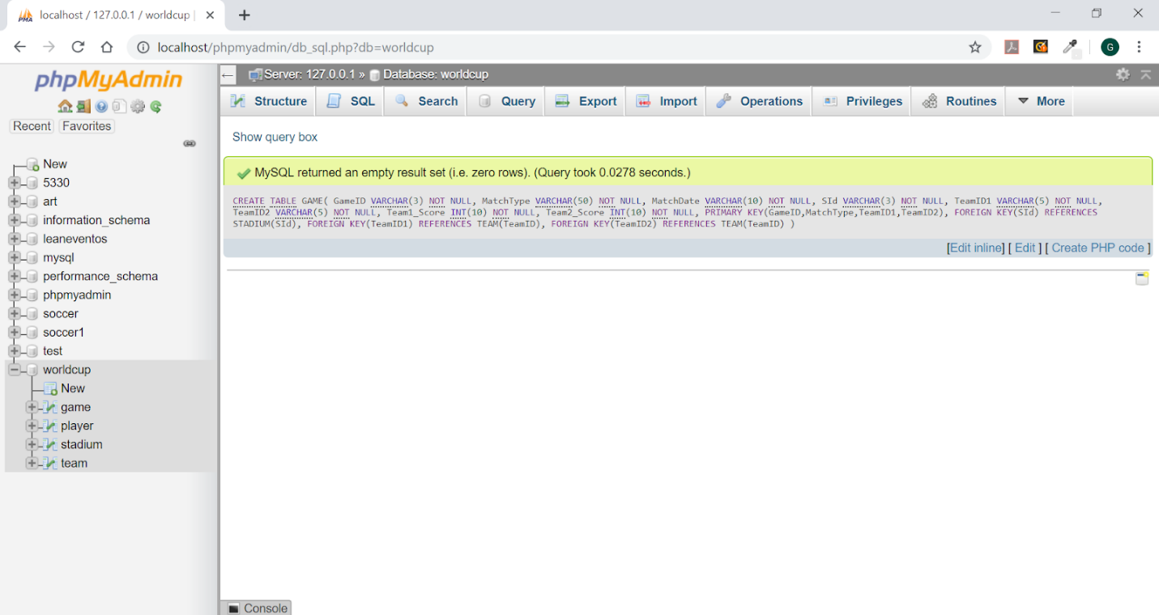

CREATE TABLE STARTING_LINEUPS(

   GameID VARCHAR(3) NOT NULL,

   TeamID VARCHAR(5) NOT NULL,

   PNo INT(10) NOT NULL,

   PRIMARY KEY(PNo, TeamID, GameID),

   FOREIGN KEY(PNo) REFERENCES PLAYER(PNo),

   FOREIGN KEY(TeamID) REFERENCES GAME(TeamID1),

   FOREIGN KEY(TeamID) REFERENCES GAME(TeamID2),

   FOREIGN KEY(GameID) REFERENCES GAME(GameID)

);

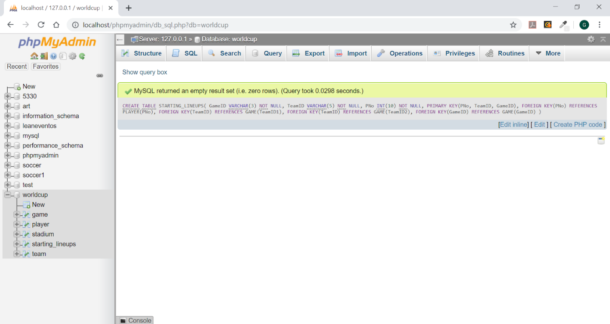

CREATE TABLE SUBSTITUTION(

   GameID VARCHAR(3) NOT NULL,

   TeamID VARCHAR(5) NOT NULL,

   PNoIn INT(10) NOT NULL,

   POSITION VARCHAR(2) NOT NULL,

   PNoOut INT(10) NOT NULL,

   TIME VARCHAR(10) NOT NULL,

   PRIMARY KEY(TeamID, PNoIn, PNoOut, GameID),

   FOREIGN KEY(PNoIn) REFERENCES PLAYER(PNo),

   FOREIGN KEY(PNoOut) REFERENCES PLAYER(PNo),

   FOREIGN KEY(TeamID) REFERENCES GAME(TeamID1),

   FOREIGN KEY(TeamID) REFERENCES GAME(TeamID2),

   FOREIGN KEY(GameID) REFERENCES GAME(GameID)

);

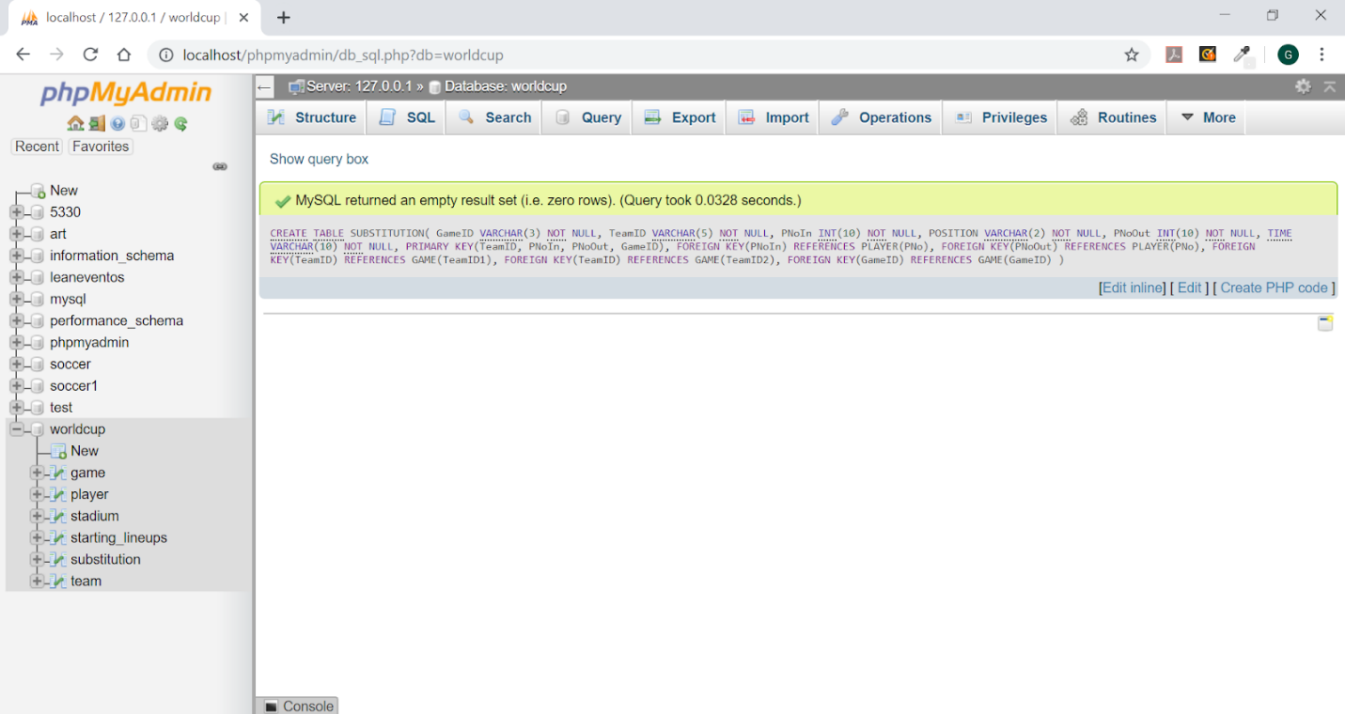

CREATE TABLE GOALS(

   GameID VARCHAR(3) NOT NULL,

   TeamID VARCHAR(5) NOT NULL,

   PNo INT(10) NOT NULL,

   TIME VARCHAR(10) NOT NULL,

   Penalty VARCHAR(2) NOT NULL,

   PRIMARY KEY(PNo, TeamID, GameID,TIME),

   FOREIGN KEY(PNo) REFERENCES PLAYER(PNo),

   FOREIGN KEY(TeamID) REFERENCES GAME(TeamID1),

   FOREIGN KEY(TeamID) REFERENCES GAME(TeamID2),

   FOREIGN KEY(GameID) REFERENCES GAME(GameID)

);

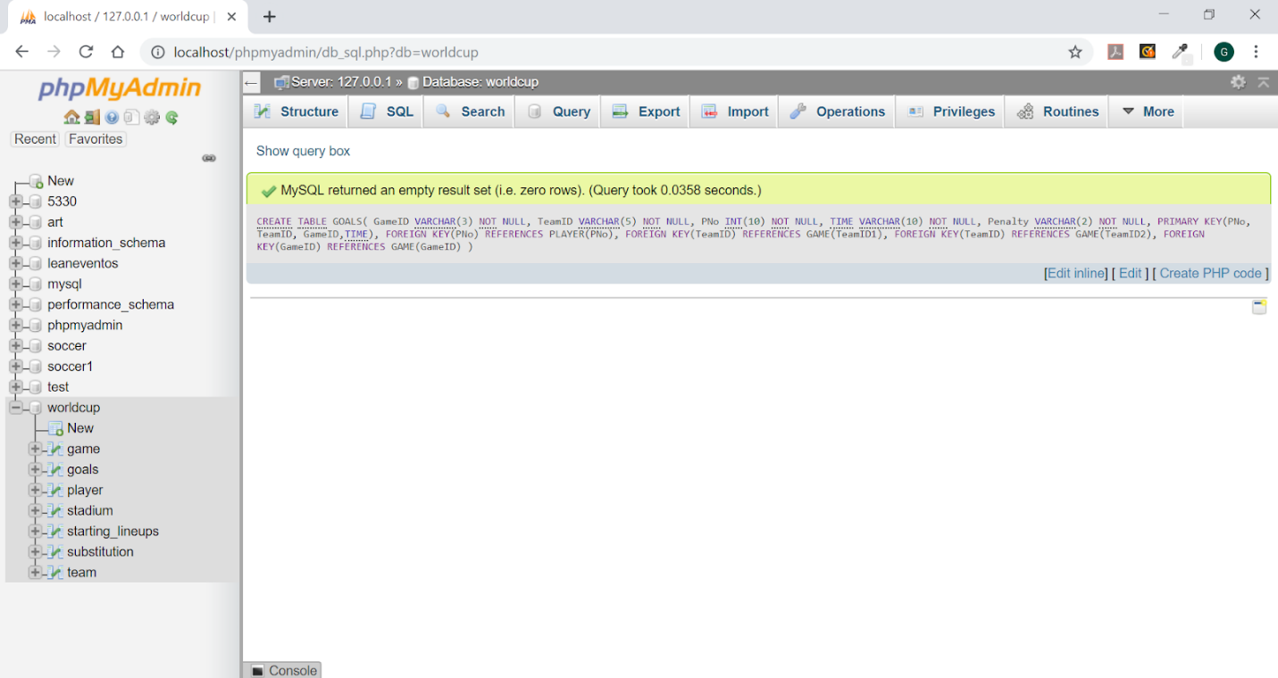

CREATE TABLE OWN_GOALS(

   GameID VARCHAR(3) NOT NULL,

   TeamID VARCHAR(5) NOT NULL,

   PNo INT(10) NOT NULL,

   TIME VARCHAR(10) NOT NULL,

   For_TeamID VARCHAR(5) NOT NULL,

   PRIMARY KEY(PNo, TeamID, GameID,TIME),

   FOREIGN KEY(PNo) REFERENCES PLAYER(PNo),

   FOREIGN KEY(TeamID) REFERENCES GAME(TeamID1),

   FOREIGN KEY(TeamID) REFERENCES GAME(TeamID2),

   FOREIGN KEY(GameID) REFERENCES GAME(GameID)

);

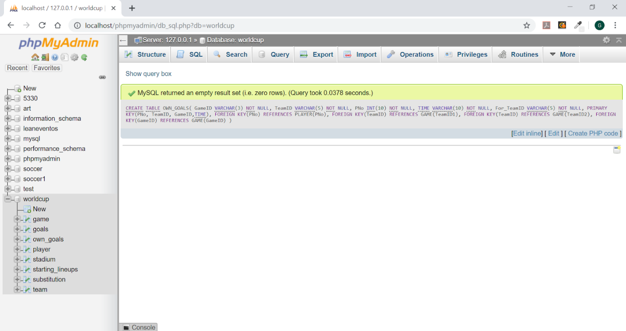

CREATE TABLE CARDS(

   GameID VARCHAR(3) NOT NULL,

   TeamID VARCHAR(5) NOT NULL,

   PNo INT(10) NOT NULL,

   Color VARCHAR(6) NOT NULL,

   TIME VARCHAR(10) NOT NULL,

   PRIMARY KEY(PNo, TeamID, GameID,TIME),

   FOREIGN KEY(PNo) REFERENCES PLAYER(PNo),

   FOREIGN KEY(TeamID) REFERENCES GAME(TeamID1),

   FOREIGN KEY(TeamID) REFERENCES GAME(TeamID2),

   FOREIGN KEY(GameID) REFERENCES GAME(GameID)

);

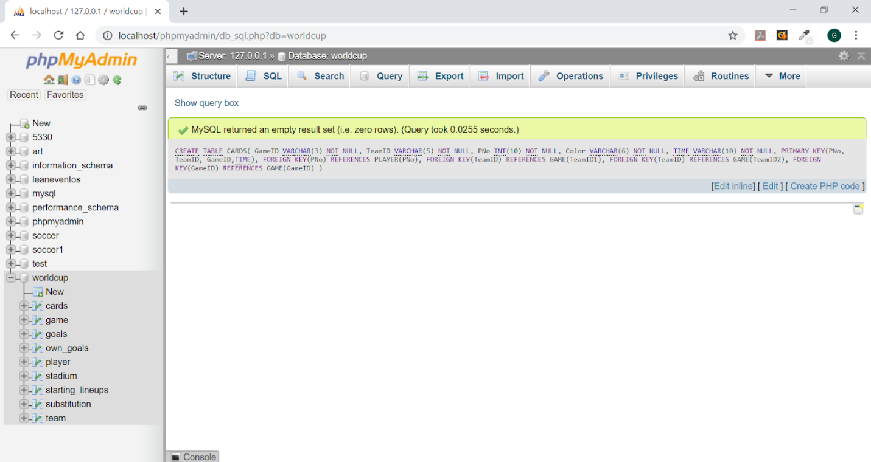

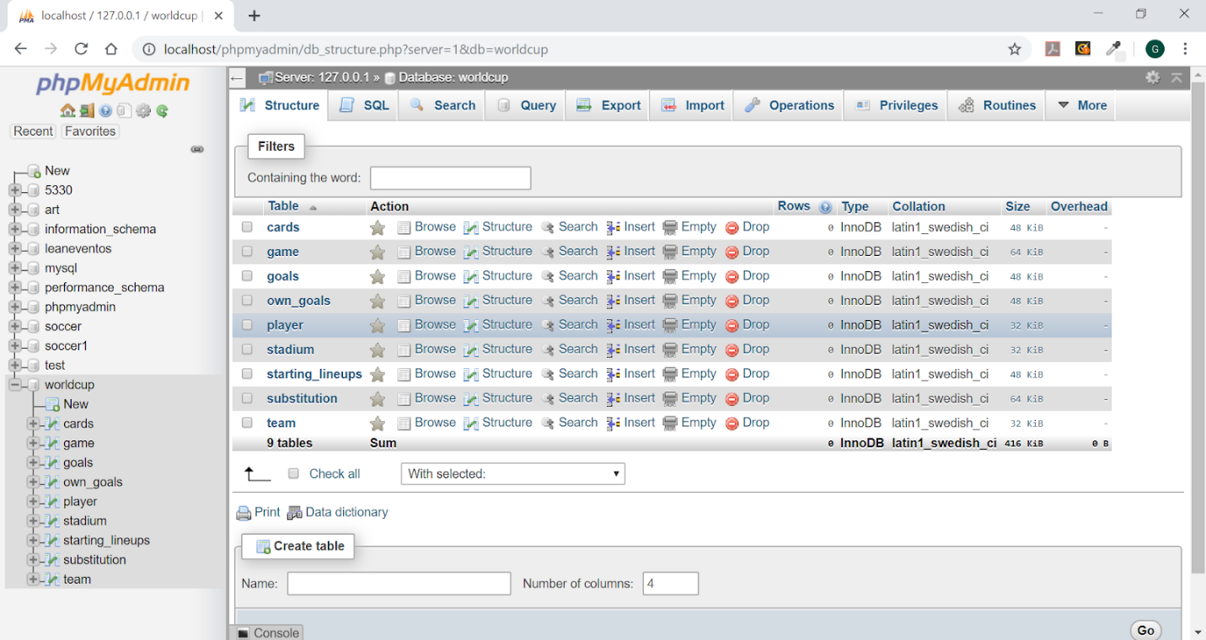

**Load Data**

LOAD DATA INFILE 'team.txt' INTO TABLE team FIELDS TERMINATED BY ',' IGNORE 1 LINES;

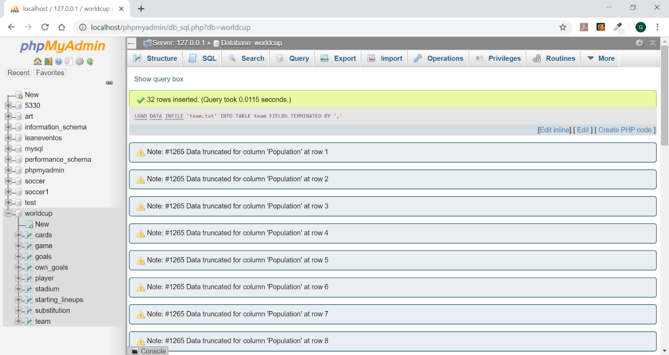

LOAD DATA INFILE 'stadium.txt' INTO TABLE stadium FIELDS TERMINATED BY ',' IGNORE 1 LINES;

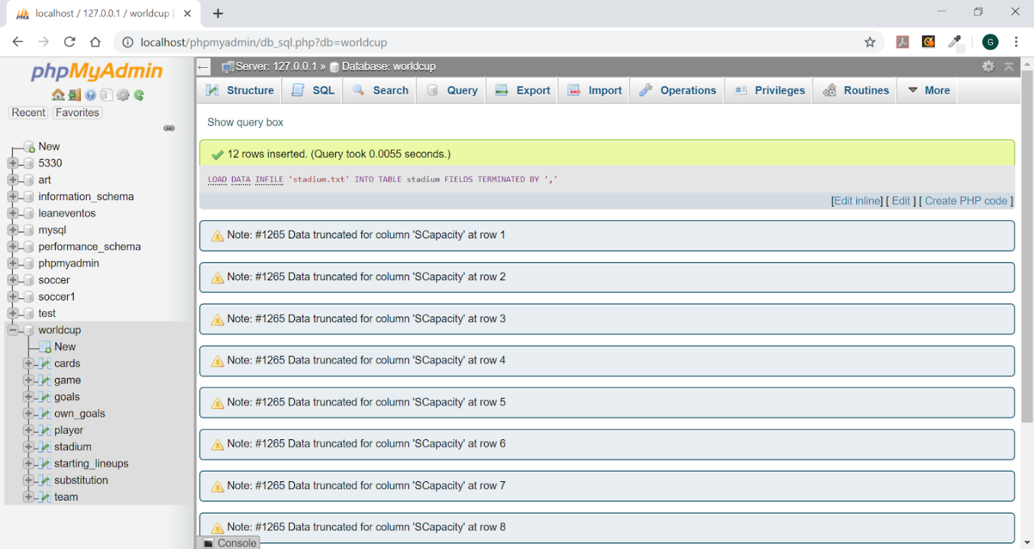

LOAD DATA INFILE 'player.txt' INTO TABLE player FIELDS TERMINATED BY ',' IGNORE 1 LINES;

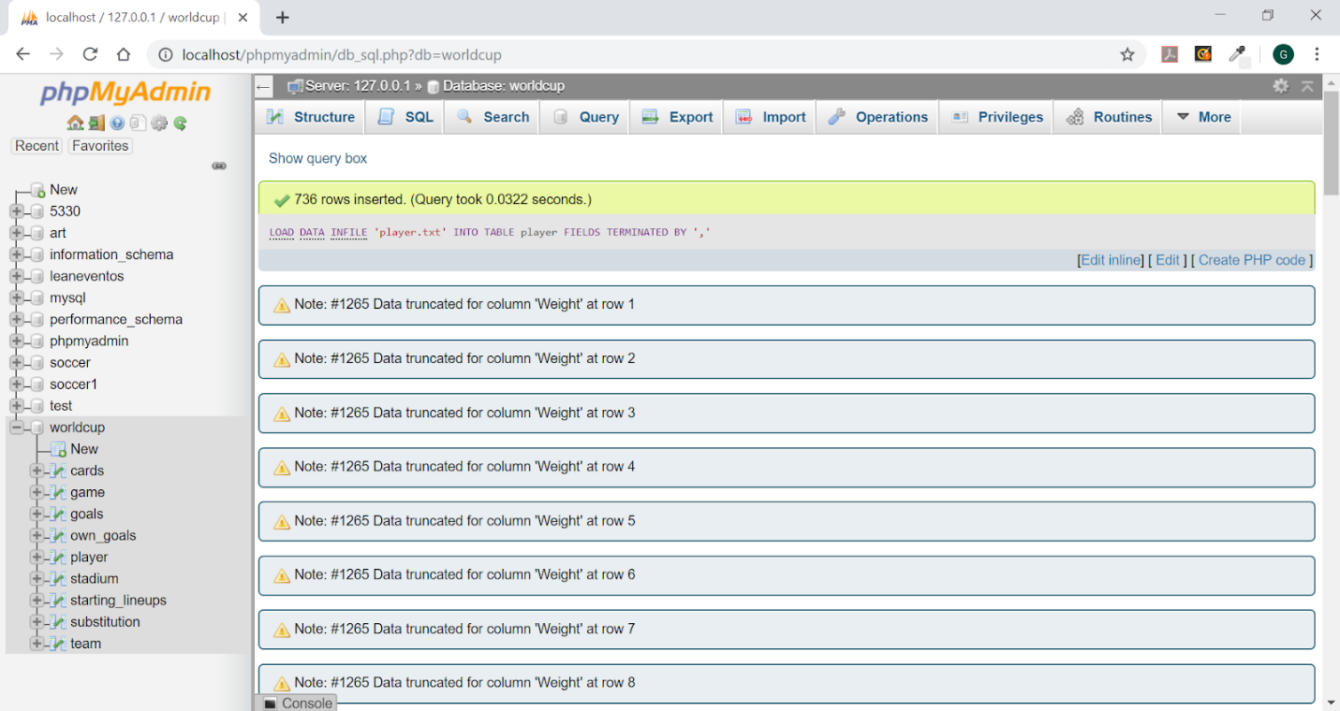

LOAD DATA INFILE 'game.txt' INTO TABLE game FIELDS TERMINATED BY ',' IGNORE 1 LINES;

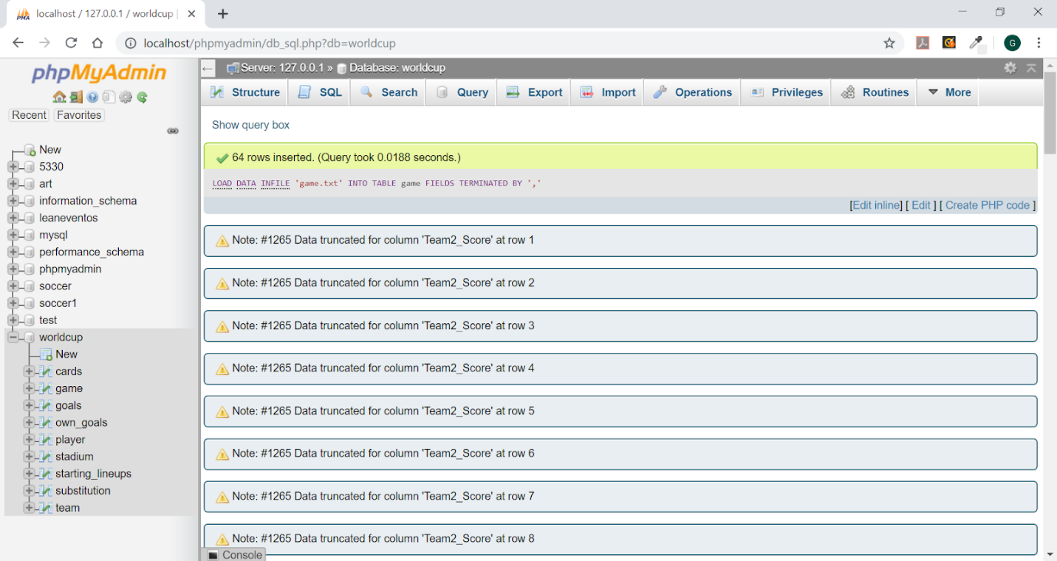

LOAD DATA INFILE 'starting_lineups.txt' INTO TABLE starting_lineups FIELDS TERMINATED BY ',' IGNORE 1 LINES;

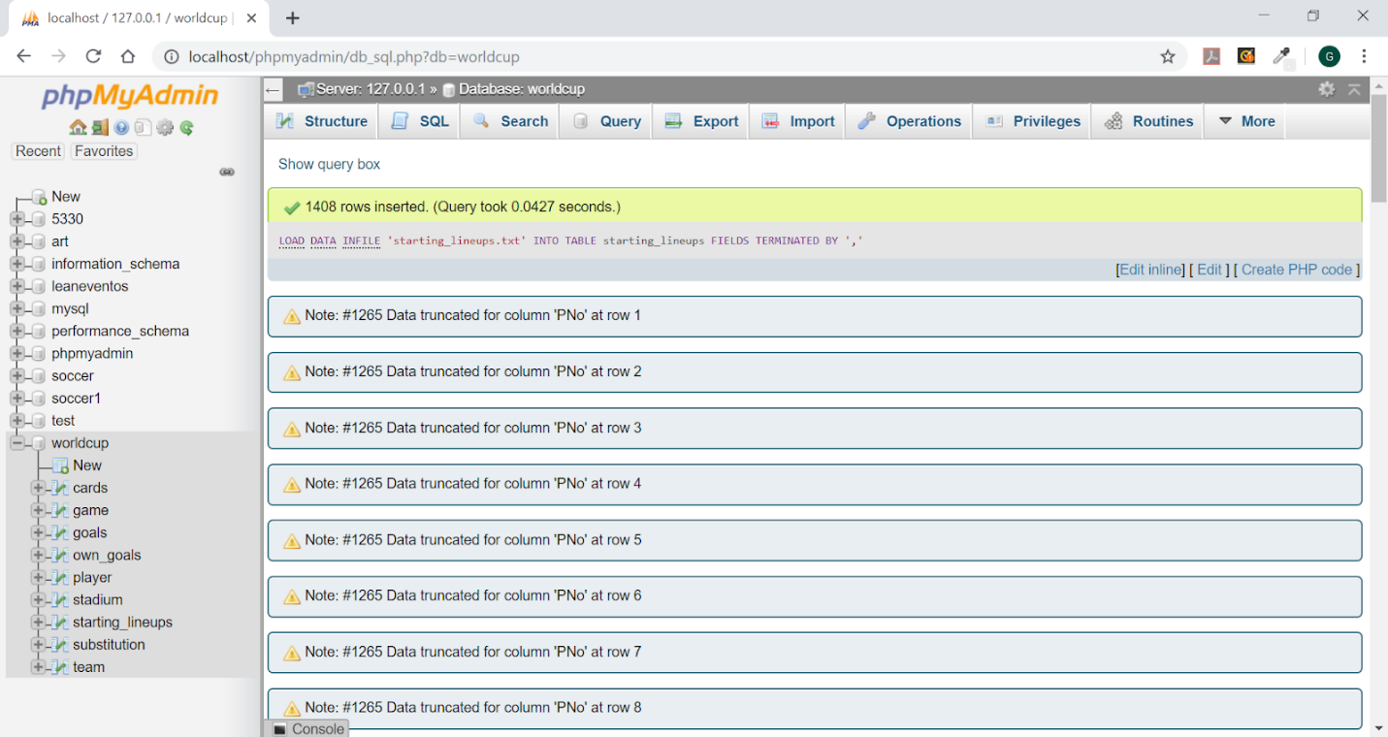

LOAD DATA INFILE 'substitution.txt' INTO TABLE substitution FIELDS TERMINATED BY ',' IGNORE 1 LINES;

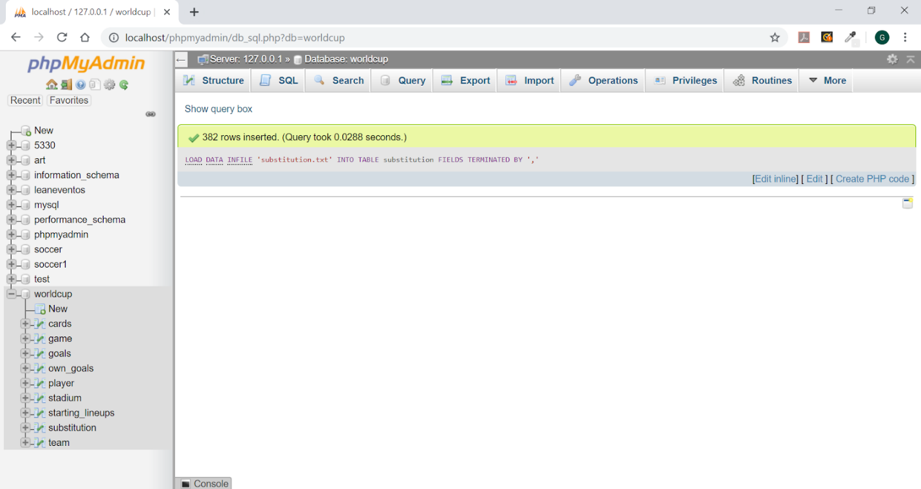

LOAD DATA INFILE 'goals.txt' INTO TABLE goals FIELDS TERMINATED BY ',' IGNORE 1 LINES;

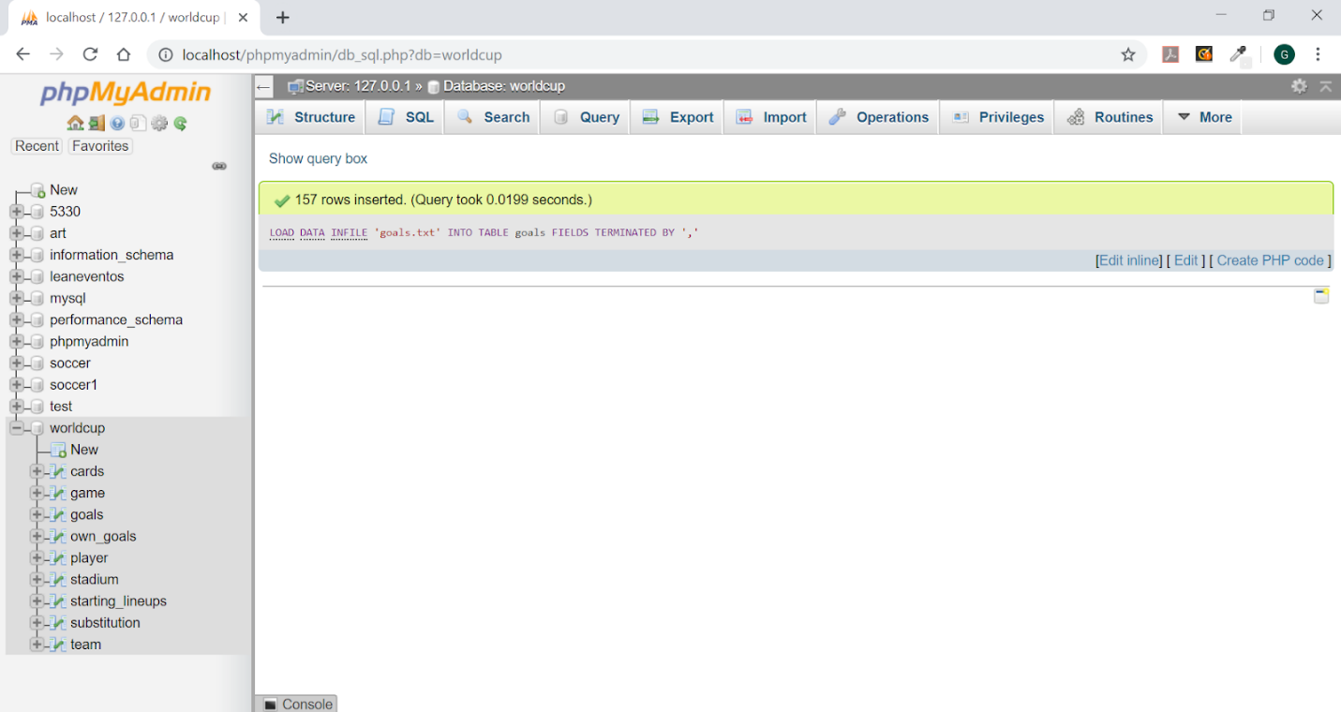

LOAD DATA INFILE 'own_goals.txt' INTO TABLE own_goals FIELDS TERMINATED BY ',' IGNORE 1 LINES;

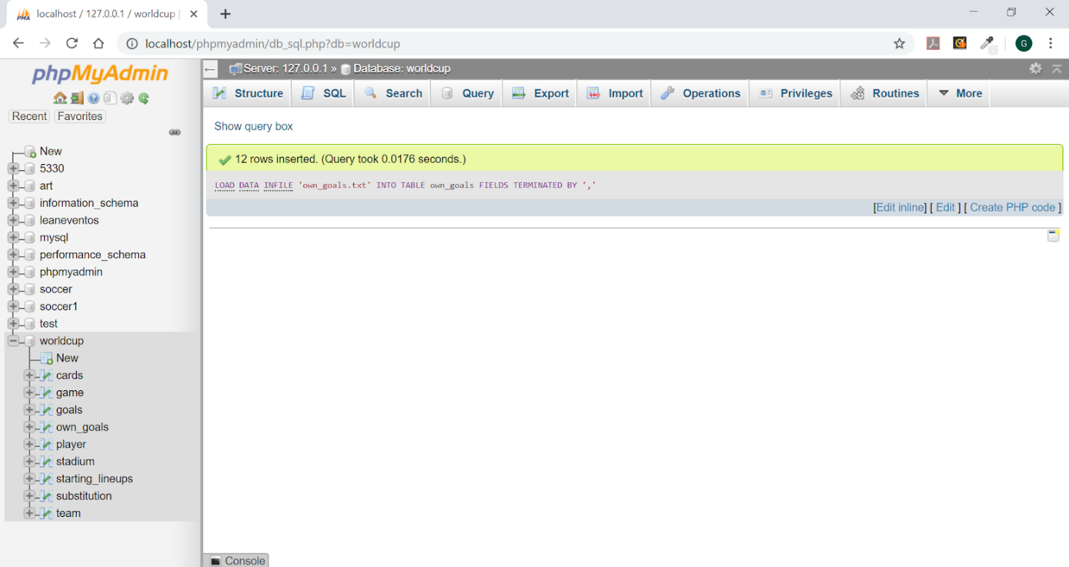

LOAD DATA INFILE 'cards.txt' INTO TABLE cards FIELDS TERMINATED BY ',' IGNORE 1 LINES;

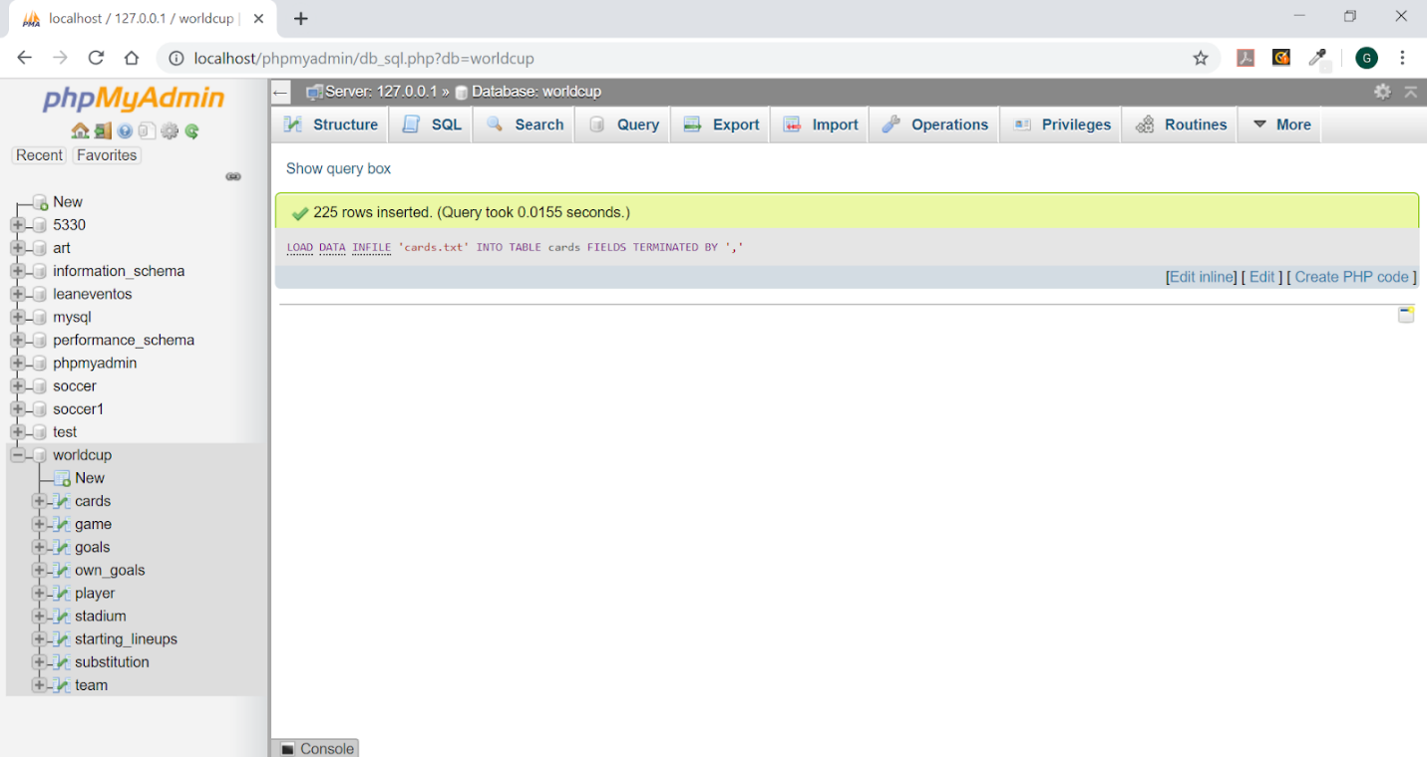

**Queries**

1. Retrieve the country, height and names of all players who hail from African continent and are taller than 190cm. Sort the list by country and their height.

SELECT P.Team,P.Height, P.PName

FROM PLAYER AS P, TEAM AS T

WHERE P.TeamID = T.TeamID AND T.Continent = 'Africa'

AND P.Height > 190

ORDER BY P.Team, P.Height;

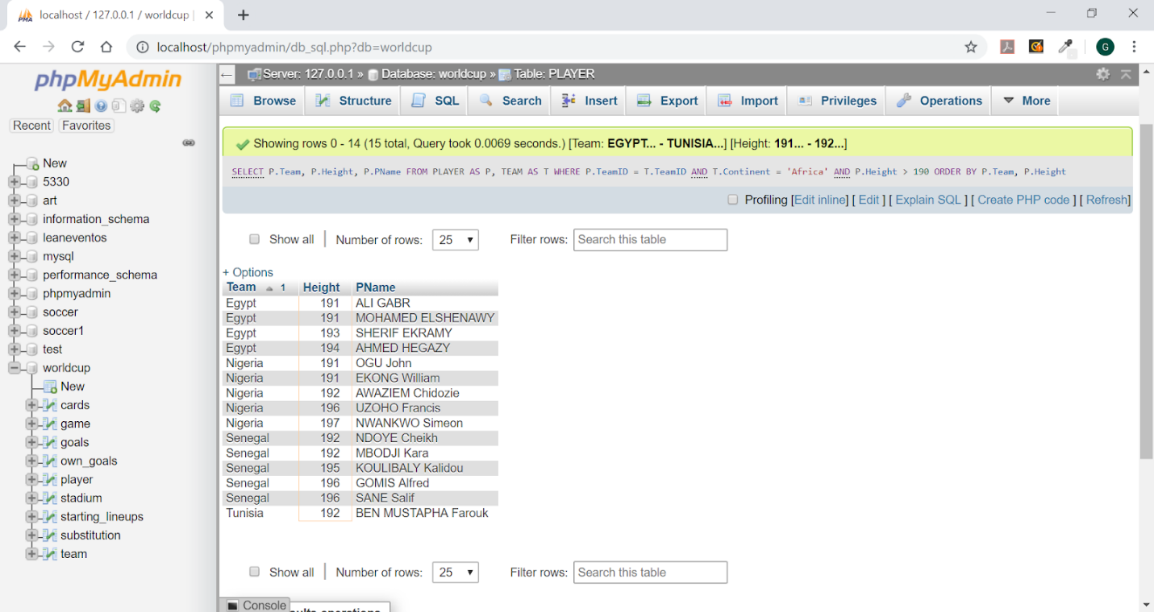

1. Retrieve the scores of all games played in Group A or B where each team had at least one score. Each result should list team 1 name, team 1 score, team 2 name, team 2 score. Sort the result by match type.

SELECT GameId,MatchType,MatchDate,TeamId1,

(SELECT B.Team from team B where B.TeamID=A.TeamID1) as Team1Name,

TeamId2,

(SELECT C.Team from team C where C.TeamID=A.TeamID2) as Team2Name,

Team1_Score,Team2_Score

FROM Game A

WHERE (A.MatchType='A' or A.MatchType='B')

AND (Team1_Score>=1 and Team2_Score>=1)

ORDER BY A.MatchType;

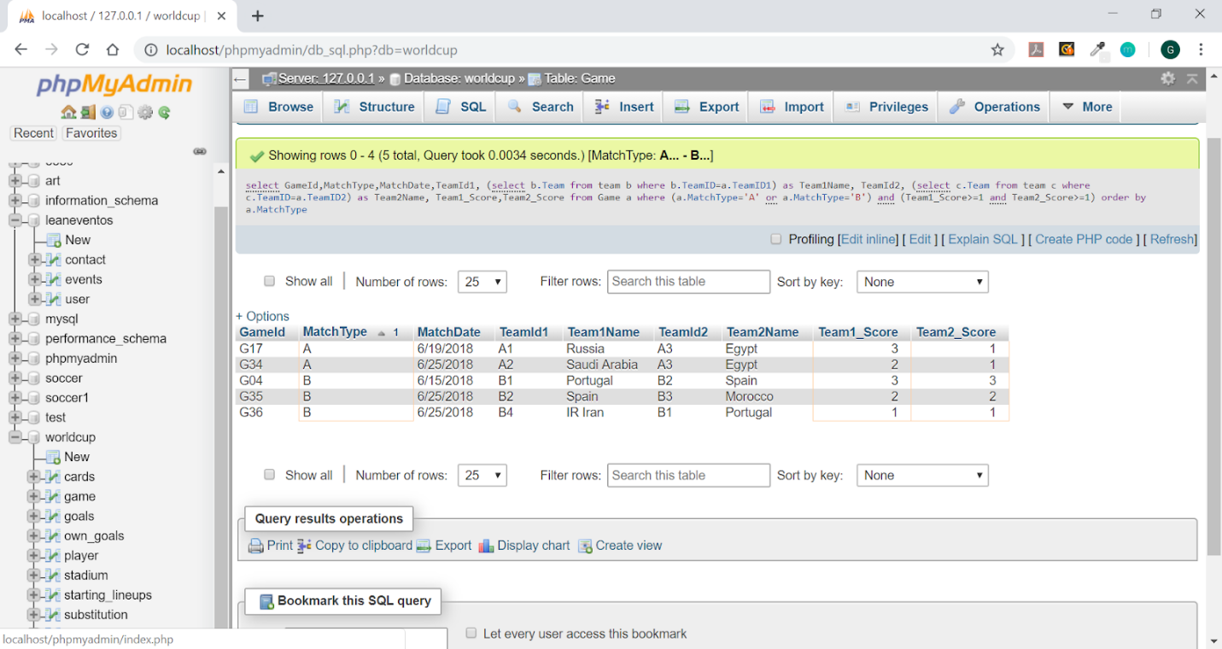

1. For all the players who received red card, retrieve their country, player name, height and weight.

SELECT P.Team, P.PName, P.Height, P.Weight

FROM PLAYER AS P, CARDS AS C

WHERE P.PNo = C.PNo AND C.Color = 'Red' and P.TeamID=C.TeamID;

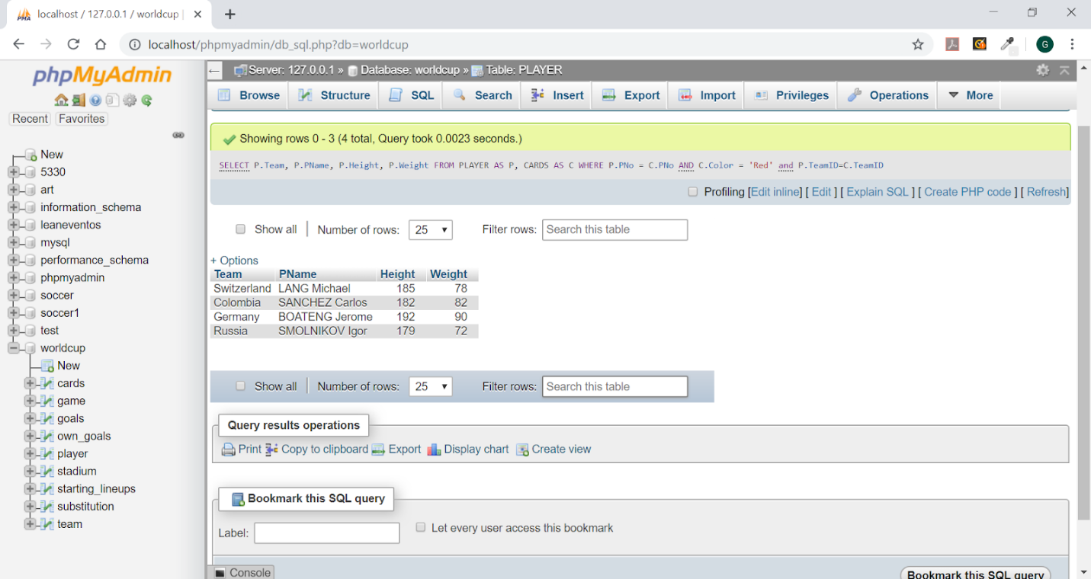

1. What is the name of the player who received the maximum number of yellow cards? How many yellow cards did he receive, and which country does he come from?

SELECT P.PName,P.Team,Count(*) as Number_Of_Yellow_Cards

FROM PLAYER P, CARDS C

WHERE P.TeamID=C.TeamID and P.PNo=C.PNo and C.Color='Yellow'

GROUP BY P.PName,P.Team

ORDER BY Number_Of_Yellow_Cards DESC LIMIT 1;

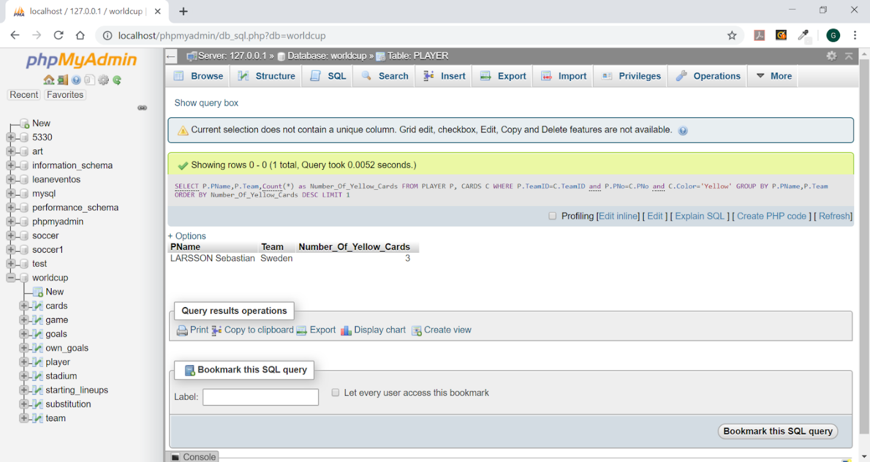

1. Retrieve the names of the teams that scored more than 1 own goals in 1 or more games. List the number of own goals that each of these teams scored.

Explanation: An own goal is an event in competitive goal-scoring sports (such as association football or hockey) where a player scores on their own side of the playing area rather than the one defended by the opponent.   https://en.wikipedia.org/wiki/Own_goal

SELECT B.Team,Count(A.GameID) as No_Of_Own_Goals

FROM OWN_GOALS A , Team B

WHERE A.TeamID=B.TeamID

GROUP BY B.TeamID

HAVING Count(A.GameID)>1;

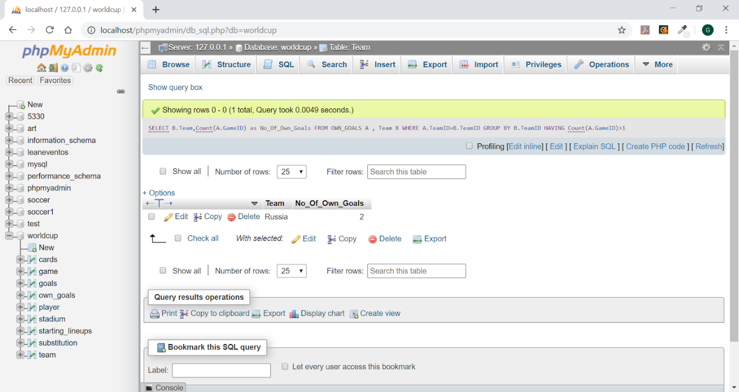

1. Create a view GAME_INFO that retrieves for each team all that team’s game scores. The view should have the following attributes: Team, and for each game that the team has participated in (either as TeamID1 or TeamID2) the following information: Match Type, MatchDate, StadiumName, SCity, Team1Name, Team1Score, Team2Name, Team2Score.

CREATE VIEW GAME_INFO AS

(SELECT G.MatchType, G.MatchDate, S.SName, S.SCity, (SELECT Team FROM TEAM T1 WHERE G.TeamID1 = T1.TeamID) AS Team1Name,

G.Team1_Score, (SELECT Team FROM TEAM T2 WHERE G.TeamID2 = T2.TeamID) AS Team2Name,

G.Team2_Score

FROM GAME G, STADIUM S

WHERE S.SId = G.SId);

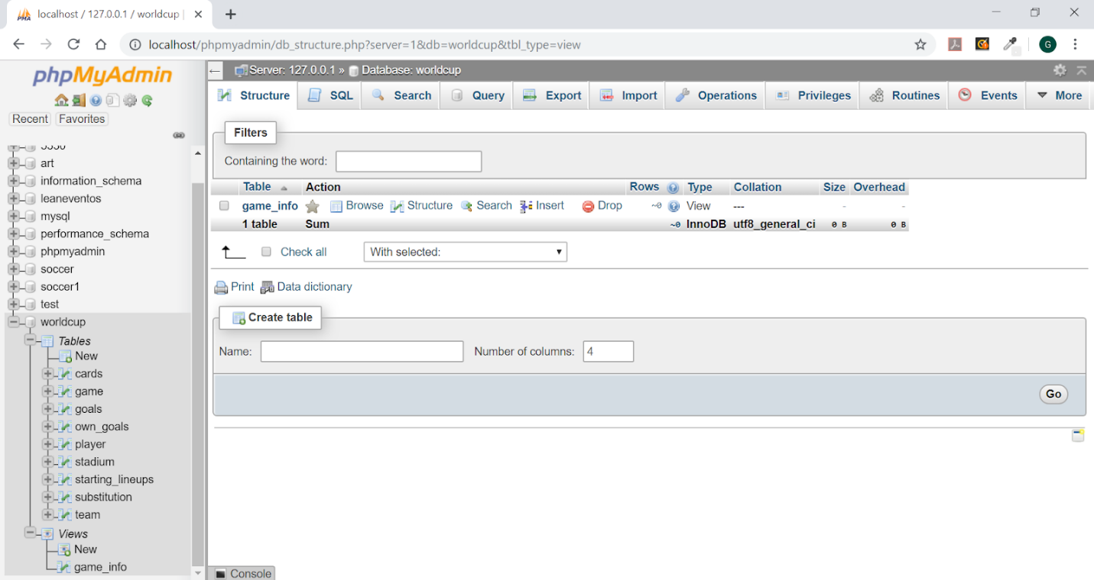

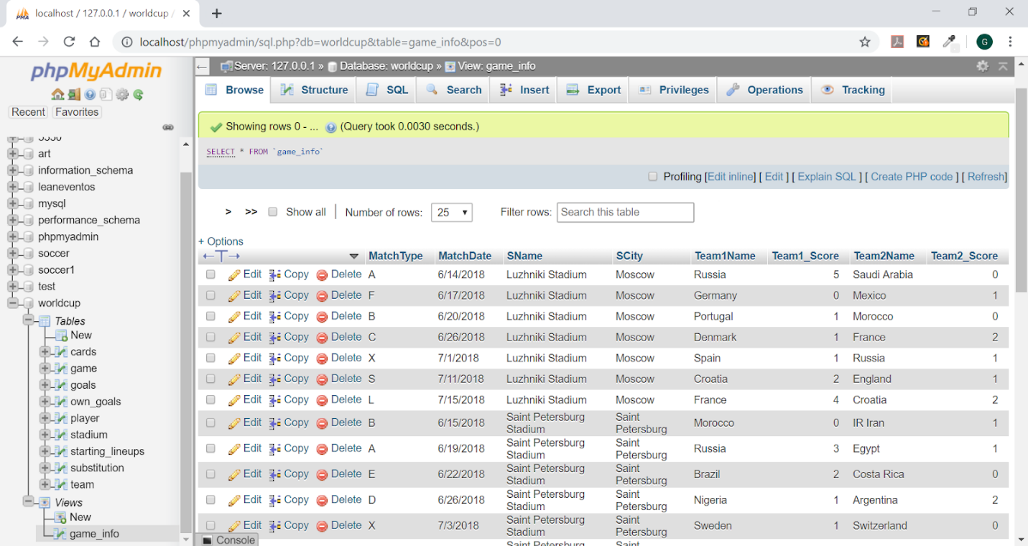

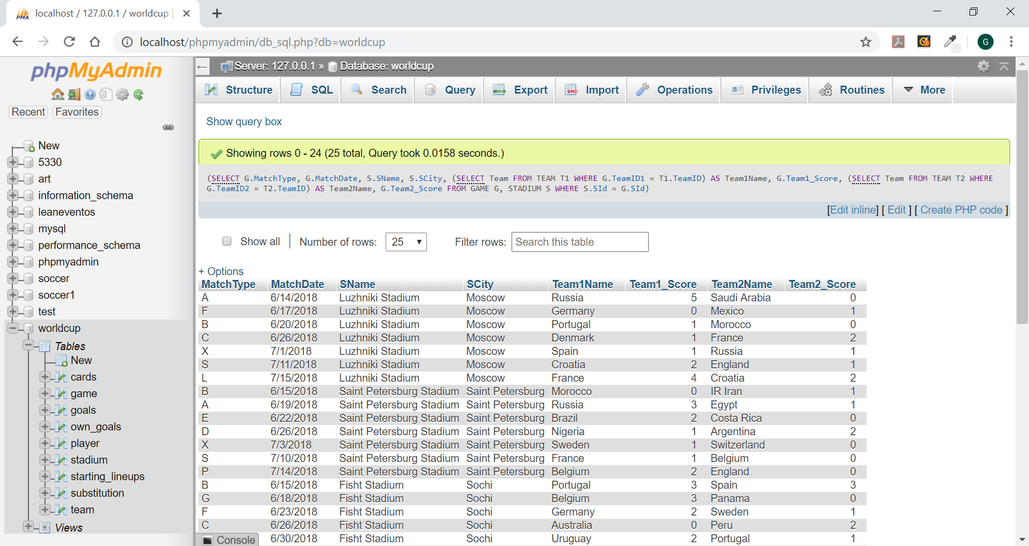

1. Write four queries in the view you created: Retrieve all game information from game_info where France played Retrieve all game information from game_info where game type is A or X Retrieve all game information from game_info where team 1 scored more than 2 goals Retrieve all game information from game_info where the stadium name has Kazan in it.

Retrieve all game information from game_info where France played:

==========================================================

SELECT *

FROM GAME_INFO

WHERE (GAME_INFO.Team1Name='France'

OR

GAME_INFO.Team2Name='France');

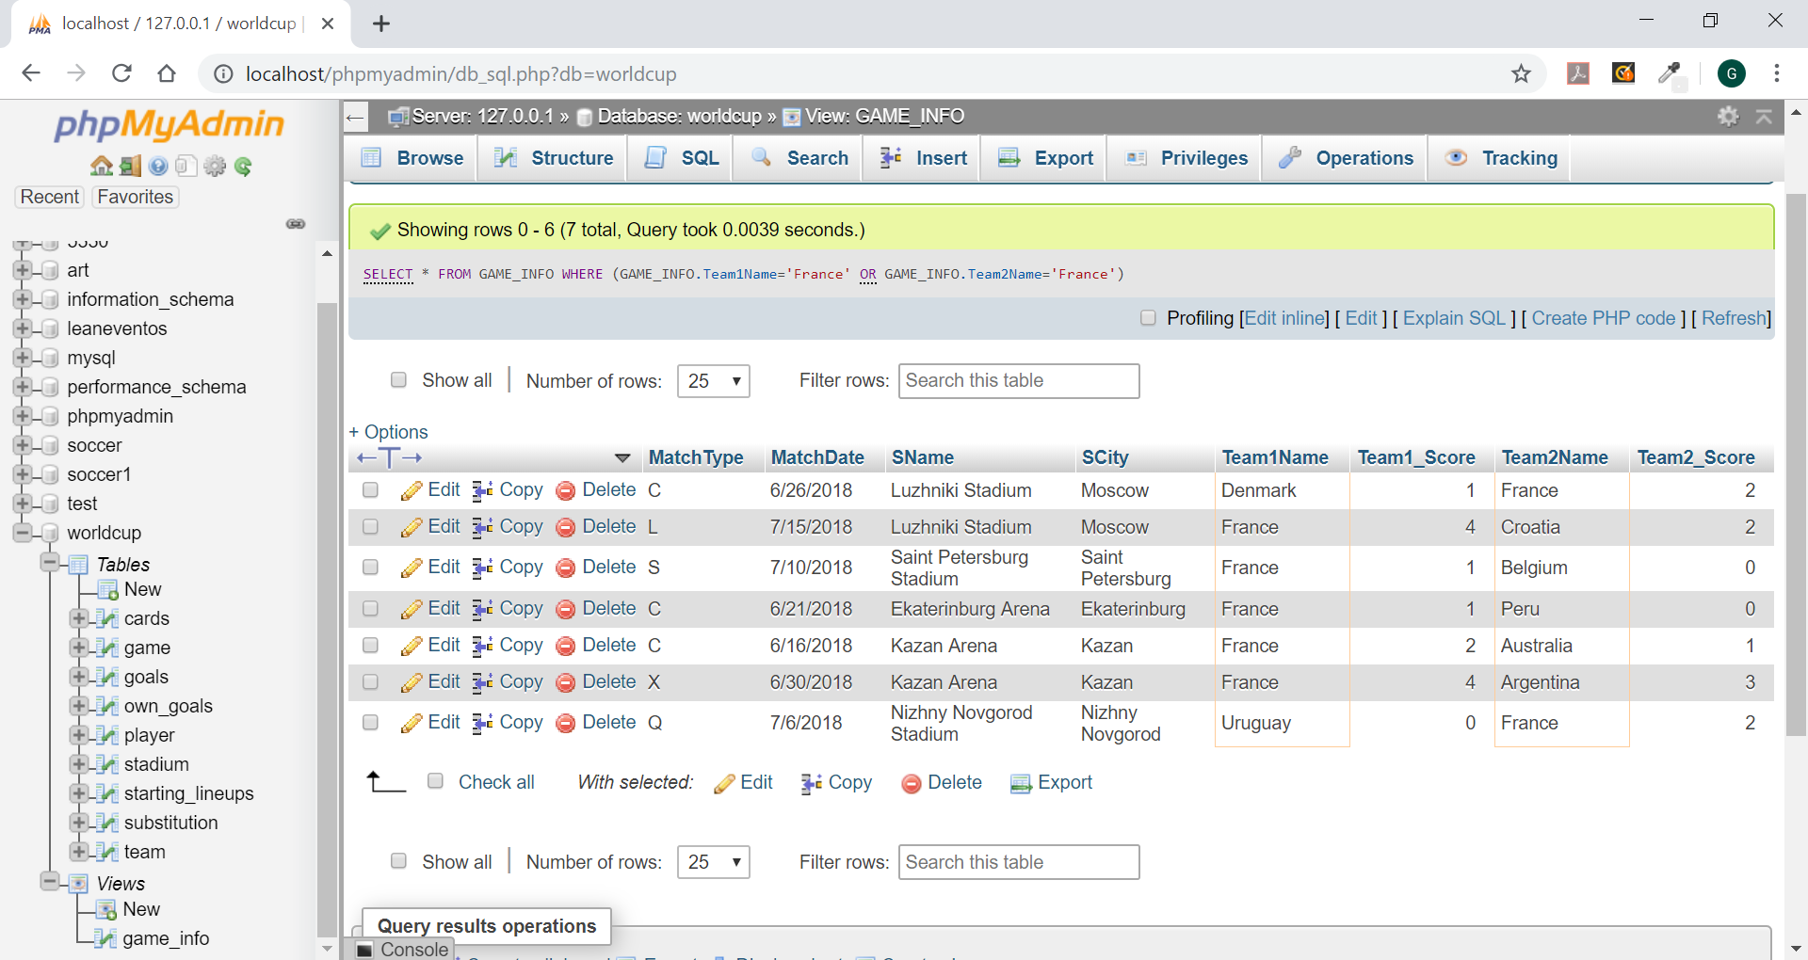

Retrieve all game information from game_info where gametype is A or X:

=================================================================

SELECT *

FROM GAME_INFO

WHERE (MatchType='A' or MatchType='X');

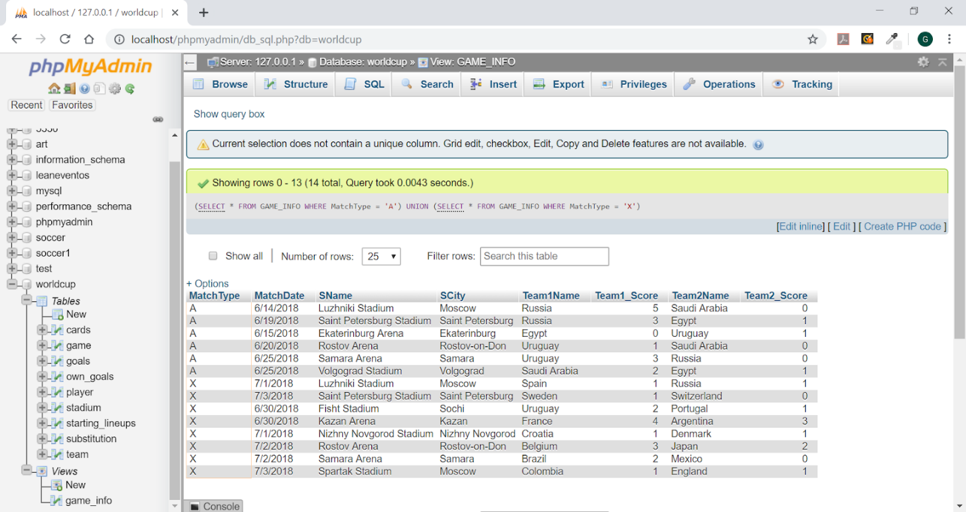

Retrieve all game information from game_info where team 1 scored more than 2 goals:

===========================================================

SELECT *

FROM GAME_INFO

WHERE Team1_Score > 2

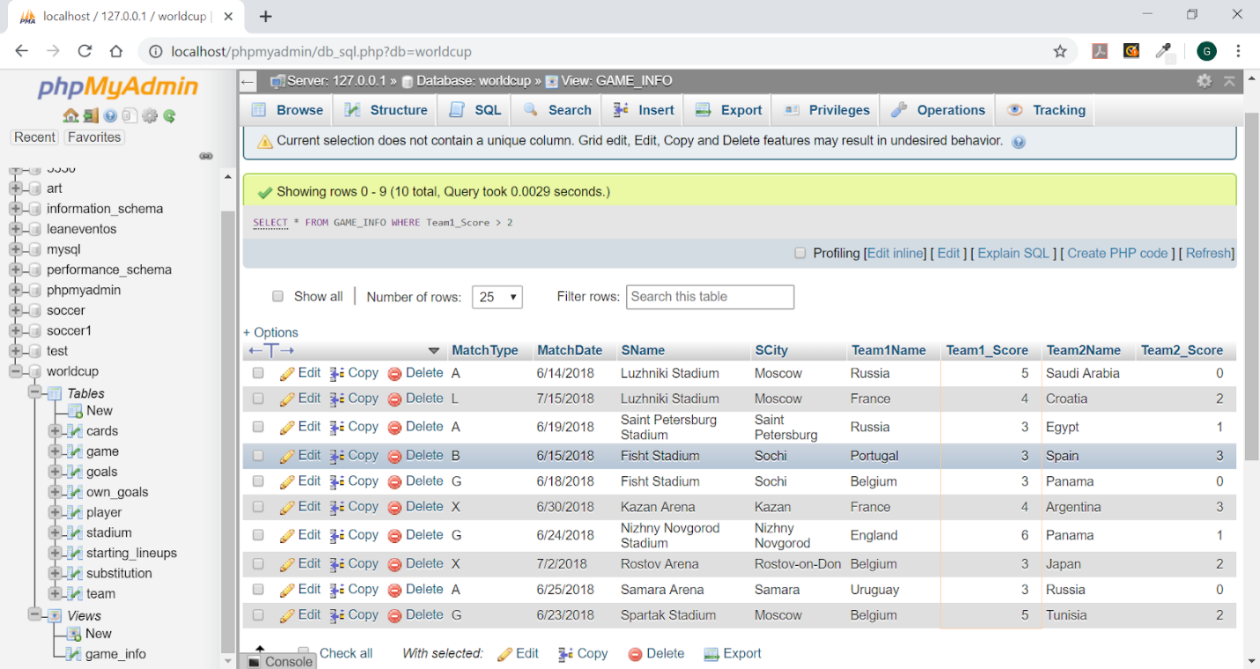

Retrieve all game information from game_info where the stadium name has Kazan in it:

==========================================================

SELECT *

FROM GAME_INFO

WHERE SName LIKE '%KAZAN%';

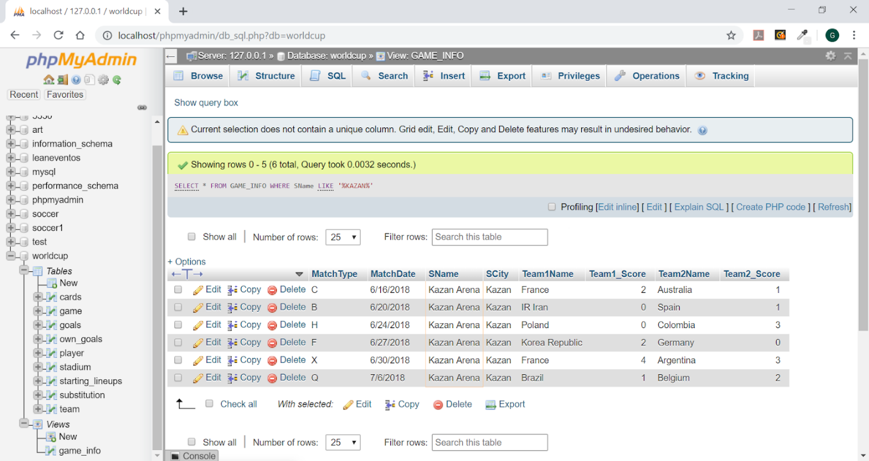

Write three additional queries on game_info and their results.

Query to list No of Games Played Citywise:

==========================================

SELECT SCity, Count(*) AS City_Count

FROM game_info

GROUP BY SCity;

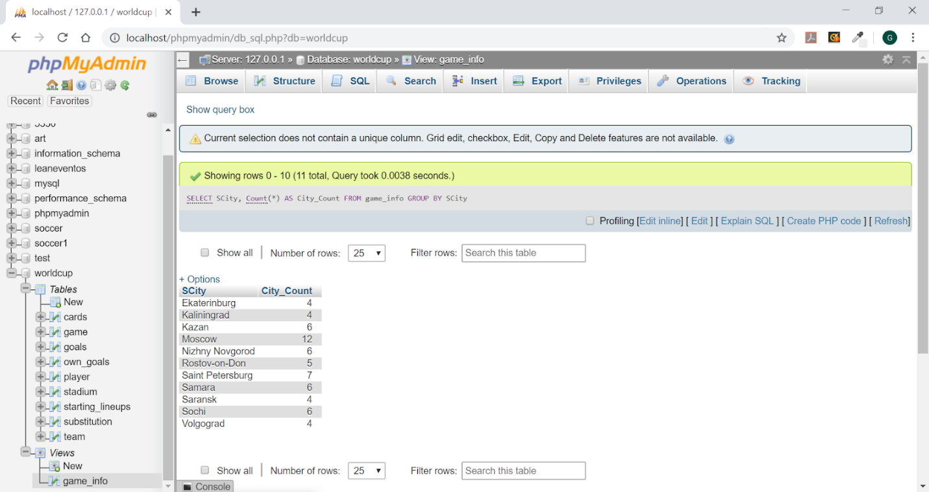

Query to retrieve all game info where match type is ‘B’

=======================================================

SELECT *

FROM GAME_INFO

WHERE MatchType = 'B';

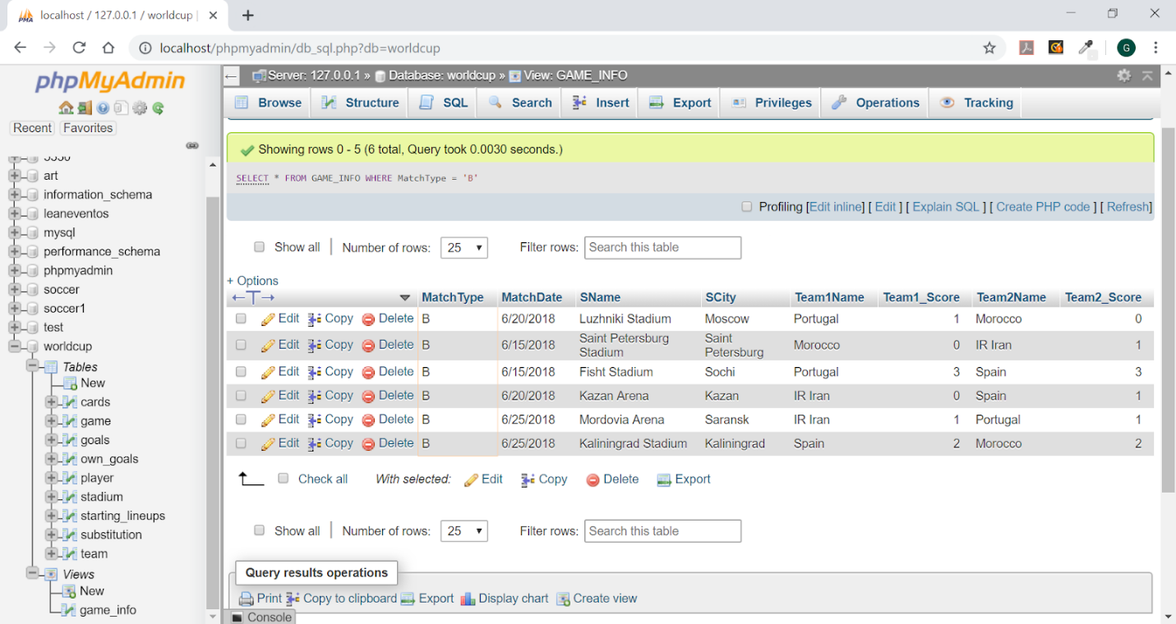

Query to retrieve all game info where match was a tie:

=====================================================

SELECT *

FROM GAME_INFO

WHERE Team1_Score=Team2_Score;

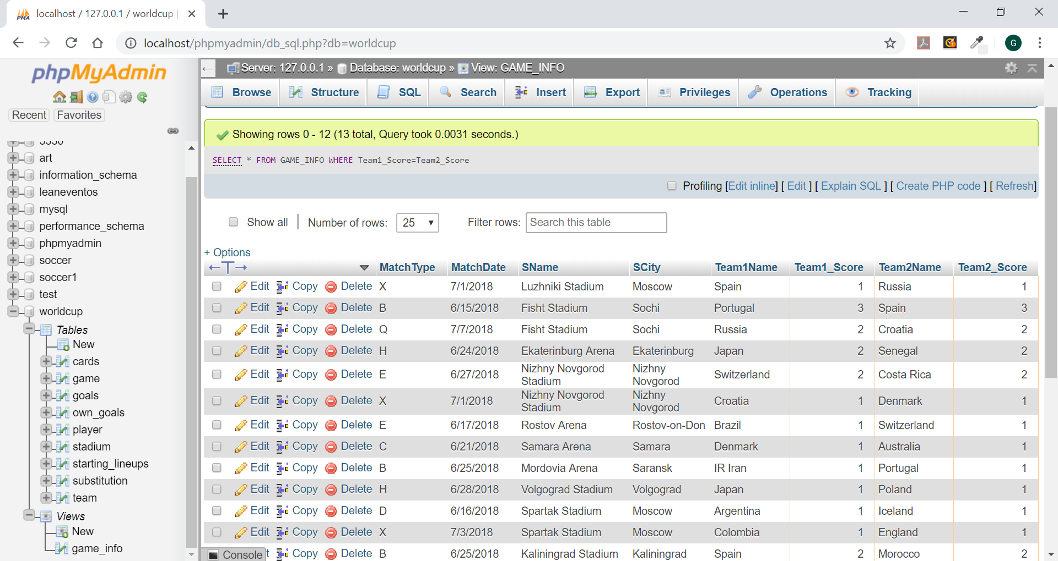

1. Write the following additional queries on the original database tables:

(i) Retrieve the name of the player and his country who received a yellow card during A game. Sort the list by country names

SELECT PName,Team

FROM PLAYER P, CARDS C

WHERE C.Color = 'Yellow' AND P.PNo = C.PNo AND P.TeamID = C.TeamID AND C.GameID IN

(SELECT GameID

FROM GAME G

WHERE G.MatchType = 'A')

ORDER BY Team;

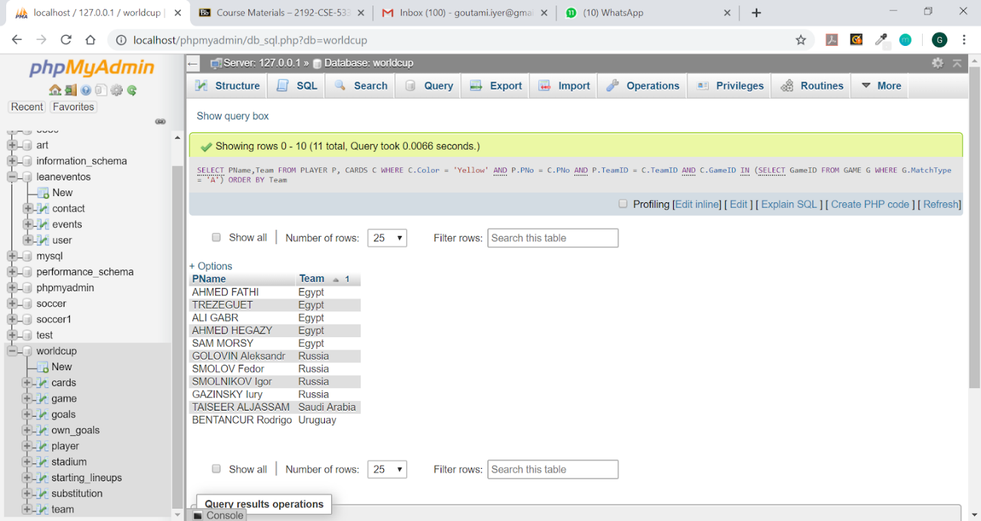

(ii) Retrieve a sorted list of the names of each country/team that played at least one game in the city of Sochi.

SELECT T.Team

FROM GAME G, STADIUM S, TEAM T

WHERE G.SId = S.SId AND S.SCity = 'Sochi' AND G.TeamID1=T.TeamID

UNION

SELECT T.Team

FROM GAME G, STADIUM S, TEAM T

WHERE G.SId = S.SId AND S.SCity = 'Sochi' AND G.TeamID2=T.TeamID

ORDER BY Team;

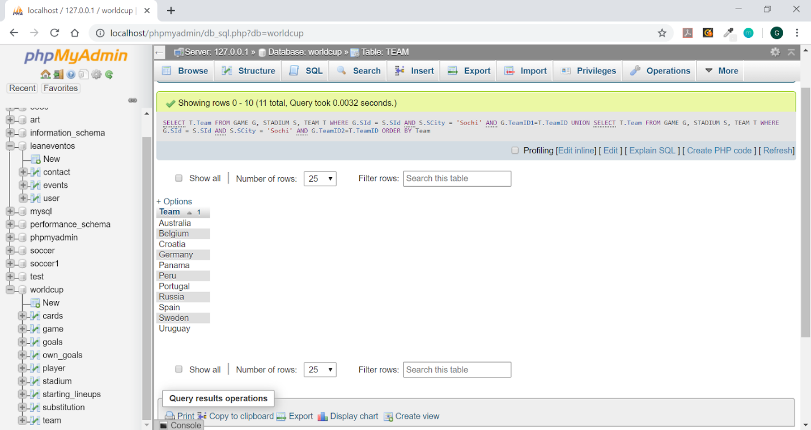

(iii) For each player who was substituted in the first 30 minutes of a game, retrieve the player name (PlayerOut) and the substitute player’s name (PlayerIn), and the minute of the substitution, as well as the team name.

SELECT (SELECT P.PName FROM PLAYER P

WHERE P.TeamID = S.TeamID AND P.PNo = S.PNoOut) AS PlayerOut, (SELECT P.PName FROM PLAYER P

WHERE P.TeamID = S.TeamID AND P.PNo = S.PNoIn) AS PlayerIn, S.TIME, P.Team

FROM SUBSTITUTION S, PLAYER P

WHERE TIME <= 30 AND P.TeamID = S.TeamID AND P.PNo = S.PNoIn;

